Bahria University,

Karachi Campus



LAB EXPERIMENT NO.

**04**

LIST OF TASKS

|  |  |
| --- | --- |
| TASK NO | OBJECTIVE |
| 01 | Where (to which window) is the output data displayed? |
| 02 | Write down the address of the first instruction of the program (see the text window). |
| 03 | Write down the value of the register $sp just before you start the program. |
| 04 | Write down the values of $a0 and $v0 before and after the execution of example “printing an integer” in Register window and explain the logic behind the changing in values? |
| 05 | Write an assembly program that read and print character. |
| 06 | Write an assembly program that prints your “favorite quote line”. |
| 07 | Write an assembly program that read and print your personal information like (name, age, gender, and phone num. etc.). |

Submitted On:

**Date: 21/10/2023**

**Task No. 01:** Where (to which window) is the output data displayed?

**Solution:**

The Output is displayed at Run I/O Window

**Output:**

**Task No. 02:** Write down the address of the first instruction of the program (see the text window).

**Solution:**

The Address of first instruction of program is 0x00400000

**Output:**

**Task No. 03:** Write down the value of the register $sp just before you start the program.

**Solution:**

The value of the register $sp before starting the program is 0x7fffeffc.

**Output:**

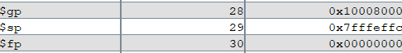

**Task No. 04:** Write down the values of $a0 and $v0 before and after the execution of example “printing an integer” in Register window and explain the logic behind the changing in values?

**Solution:**

The Value of $v0 and $a0 before execution the program is 0x00000000 and 0x00000000.

The Value of $v0 and $a0 after execution the program is 0x0000000a and 0x0000002d.

$v0 is a frequently employed register for retaining the outcome of a function call when a system call is initiated. When you engage in a system call to display an integer, like using syscall code 1 (for the purpose of integer printing), it is anticipated that you will put the integer you wish to print into $a0. Subsequently, the system call will execute the printing of the integer and might also deliver a result in $v0, which can be employed for inspecting errors or other pertinent data, contingent upon the particular system call being used.

**Output:**

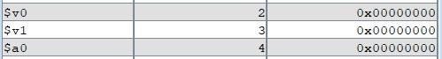

**Task No. 05:** Write an assembly program that read and print character.

**Solution:**

.data

input: .asciiz"Enter Your Character:"

output: .asciiz "\nCharacter you entered is:"

charSpace:.space 3

.text

main:

li $v0,4

la $a0,input

syscall

li $v0 , 8

la $a0,charSpace

li $a1, 3

syscall

li $v0, 4

la $a0, output

syscall

li $v0, 4

la $a0, charSpace

syscall

li $v0,10

syscall

**Output:**

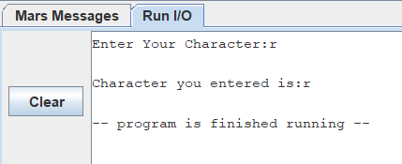

**Task No. 06:** Write an assembly program that prints your “favorite quote line”.

**Solution:**

.data

text: .asciiz "My favourite motivational quote is:\nTipu Sultan Qoute:\nOne day's life of a lion is preferable to hundred years of a jackal."

.text

la $a0,text

li $v0, 4

syscall

li $v0, 10

syscall

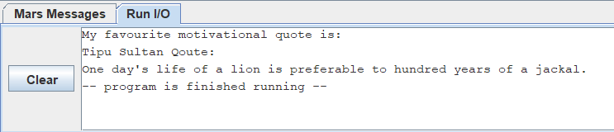**Output:**

**Task No. 07:** Write an assembly program that read and print your personal information like (name, age, gender, and phone num. etc.).

**Solution:**

.data

inputName: .asciiz"Enter Your Name:"

inputage: .asciiz"Enter Your Age:"

inputgender: .asciiz"Enter Your Gender:"

input: .asciiz"Enter Your Contact No:"

nameOutPrompt: .asciiz "Name:"

ageOutPrompt: .asciiz "Age:"

genderOutPrompt: .asciiz "\nGender:"

phoneOutPrompt: .asciiz "Phone Number:"

nameSpace: .space 30

genderSpace: .space 10

phoneSpace: .space 13

.text

main:

li $v0, 4

la $a0,inputName

syscall

li $v0, 8

la $a0, nameSpace

li $a1, 30

syscall

li $v0, 4

la $a0, inputage

syscall

li $v0, 5

syscall

move $t0,$v0

li $v0, 4

la $a0, inputgender

syscall

li $v0, 8

la $a0, genderSpace

li $a1,10

syscall

li $v0, 4

la $a0, input

syscall

li $v0, 8

la $a0, phoneSpace

li $a1, 13

syscall

li $v0, 4

la $a0, nameOutPrompt

syscall

li $v0, 4

la $a0, nameSpace

syscall

li $v0, 4

la $a0, ageOutPrompt

syscall

li $v0, 1

move $a0,$t0

syscall

li $v0, 4

la $a0, genderOutPrompt

syscall

li $v0, 4

la $a0, genderSpace

syscall

li $v0, 4

la $a0, phoneOutPrompt

syscall

li $v0, 4

la $a0,phoneSpace

syscall

li $v0, 10

syscall

**Output:**

